**1.** List the item number, description, and price for all item. 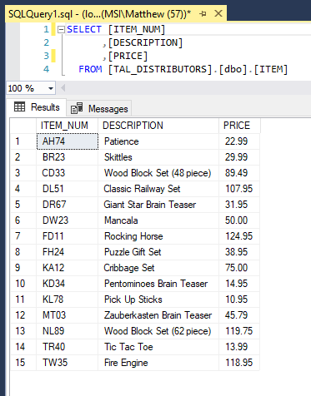

**2.** List all rows and columns for the complete ORDERS table. 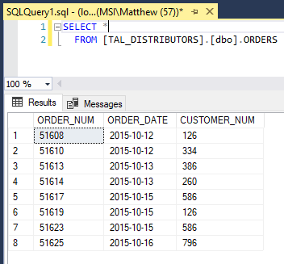

**3**. List the names of customers with credit limits of $10,000 or more. 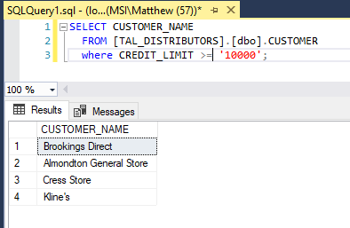

**4.** List the order number for each order placed by customer number 126 on 10/15/2015. (Hint: If you need help, use the discussion of the DATE data type in Figure 3-16 in Chapter 3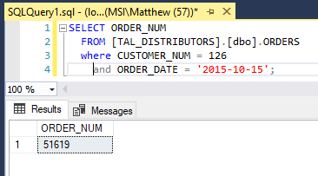

**5.** List the number and name of each customer represented by sales rep 30 or sales rep 45. 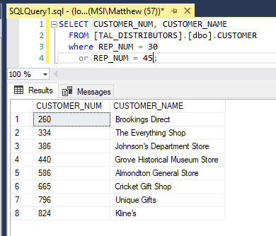

**6.** List the item number and description of each item that is not in category PZL. 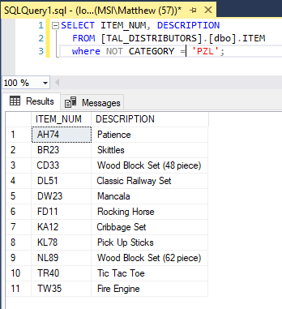

**7.** List the item number, description, and number of units on hand for each item that has between 20 and 40 units on hand, including both 20 and 40. Do this two ways. 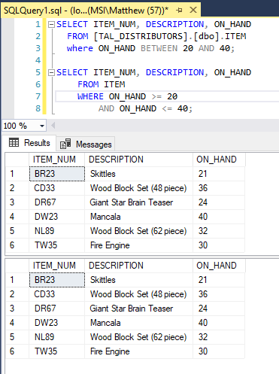

**8.** List the item number, description, and on-hand value (units on hand * unit price) of each item in category TOY. (On-hand value is really units on hand * cost, but there is no COST column in the ITEM table.) Assign the name ON_HAND_VALUE to the computed column. 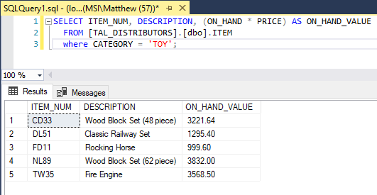

**9.** List the item number, description, and on-hand value for each item whose on-hand value is at least $1,500. Assign the name ON_HAND_VALUE to the computed column. 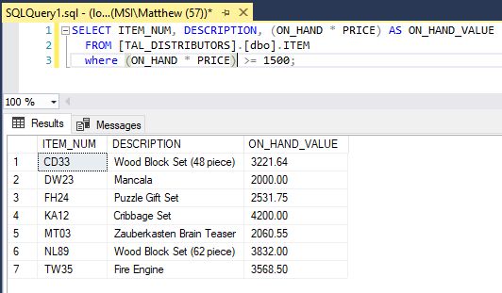

**10.** Use the IN operator to list the item number and description of each item in category GME or PZL. 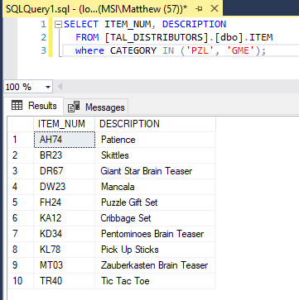

**11.** Find the number and name of each customer whose name begins with the letter “C".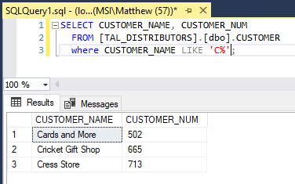

**12**. List all details about all parts. Order the output by part description. 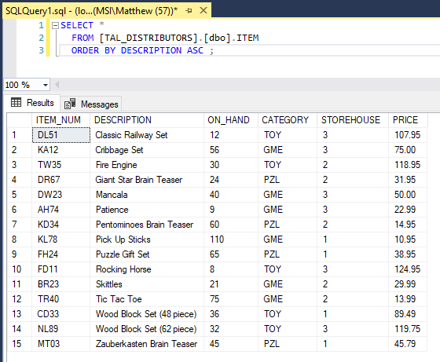

**13.** List all details about all items. Order the output by item number within storehouse. (That is, order the output by storehouse and then by item number.) 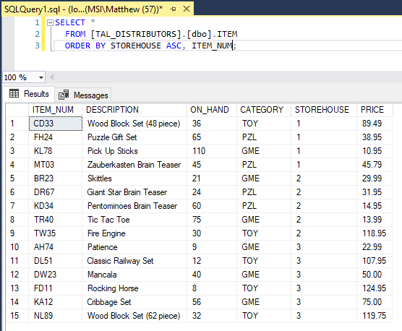

**14.** How many customers have balances that are more than their credit limits? 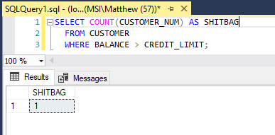

**15.** Find the total of the balances for all customers represented by sales rep 15 with balances that are less than their credit limits. 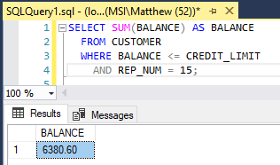

**16.** List the item number, description, and on-hand value of each item whose number of units on hand is more than the average number of units on hand for all items. (Hint: Use a subquery.) 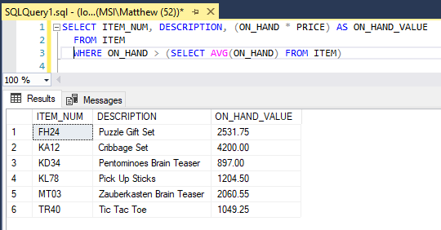

**17.** What is the price of the least expensive item in the database? 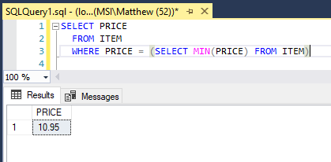

**18.** What is the item number, description, and price of the least expensive part in the database?  
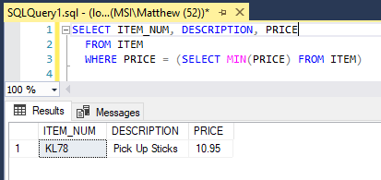

**19.** List the sum of the balances of all customers for each sales rep. Order and group the results by sales rep number. 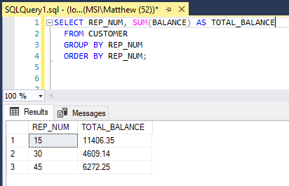

**20.** List the sum of the balances of all customers for each sales rep, but restrict the output to those sales reps for which the sum is more than $5,000. Order the results by sales rep number. 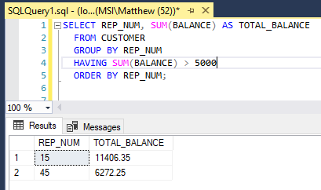

**21.** List the part number of any part with an unknown description. 